|  |
| --- |
| fA  PROJECT REPORT  on    AI DRIVEN AGRIBOT    SUBMITTED TO AN AUTONOMOUS INSTITUTE, AFFILIATED TO  SAVITRIBAI PHULE PUNE UNIVERSITY, PUNE IN THE PARTIAL  FULFILLMENT OF THE REQUIREMENTS FOR THE AWARD OF THE DEGREE  BACHELOR OF TECHNOLOGY  in  (Electronics & Telecommunication Engineering)    SUBMITTED BY    VAIBHAV NRUPNARAYAN Reg. No :2021AETN1101136  HARISH BAGUL Reg. No :2021AETN1111122  ABHIMAN BADE Reg. No :2021AETN1101076        Under the Guidance of  DR. KAVITA JOSHI      DEPARTMENT OF ELECTRONICS & TELECOMMUNICATION ENGINEERING    G H RAISONI COLLEGE OF ENGINEERING AND MANAGEMENT  WAGHOLI, PUNE 412207    AY: 2024-25 (Winter) |



# CERTIFICATE

This is to certify that the project report entitled

“AI DRIVEN AGRIBOT”

Submitted by

VAIBHAV NRUPNARAYAN Reg. No :2021AETN1101136

HARISH BAGUL Reg. No :2021AETN1111122

ABHIMAN BADE Reg. No :2021AETN1101076

are a Bonafide students of this institute and the work has been carried out by them under the supervision of (DR. KAVITA JOSHI) and it is approved for the partial fulfillment of the requirement of an Autonomous Institute, Affiliated to Savitribai Phule Pune University, for the award of the degree of Bachelor of Technology in Electronics & Telecommunication Engineering in the academic year 2024-25.

(DR. KAVITA JOSHI) (Dr. S. K. Waghmare) Guide H.O.D.

(……………………….) (Dr. R. D. Kharadkar)

External Examiner Director

GHRCEM, Pune

Date:

Place: Pune



# DECLARATION BY THE STUDENT(S)

We declare that our the project entitled "AI DRIVEN AGRIBOT” submitted by us for the award of degree Bachelor of Technology in Electronics & Telecommunication

Engineering is the record of work carried out by during the period from July, 2023 to December 2023 under the guidance of DR. Kavita Joshi and has not formed the basis for the award of any degree, diploma, associate ship, fellowship, titles in this or any other University or other institution of higher learning.

We further declare that the material obtained from other sources has been, duly acknowledged

in the thesis.

VAIBHAV NRUPNARAYAN Reg. No :2021AETN1101136

HARISH BAGUL Reg. No :2021AETN1111122

ABHIMAN BADE Reg. No :2021AETN1101076

Date: / /

Place: Pune

# ACKNOWLEDGMENT

It gives us great pleasure in presenting AI DRIVEN AGRIBOT as our B.Tech. project. Words have never seemed as inadequate as now when we are endeavoring to express our gratitude at the culmination of our B.Tech. Project to all those who have made it possible. Even the best efforts are waste, without the proper guidance and advice of our project guide DR. KAVITA JOSHI for the consistent guidance, co-operation, inspiration, practical approach and constructive criticism, which provided us the much needed impetus to work hard & also thanks Dr. S. K. Waghmare Head of E&TC Department for their continuous support & valuable suggestions..

We take this opportunity to thank our Campus Director Dr. R. D. Kharadkar for their whole hearted support, motivation & valuable suggestions.

We would also like to thank Dr. S. D. Hanwate our Project Coordinator for her valuable support in providing us with the required information.

At the end, we would like to give special thanks to all staff members from E&TC Department of G H Raisoni College of Engineering and Management, Pune & our colleagues for their kind support & timely suggestions.

VAIBHAV NRUPNARAYAN Reg. No :2021AETN1101136

HARISH BAGUL Reg. No :2021AETN1111122

ABHIMAN BADE Reg. No :2021AETN1101076

# ABSTRACT

The AI-driven Agribot project presents an innovative solution to modernize rice farming by integrating Artificial Intelligence (AI) and Internet of Things (IoT) technologies to automate rice planting, environmental monitoring, and crop management. Traditional rice cultivation is labor-intensive, time-consuming, and prone to inefficiencies, resulting in higher costs, inconsistent planting, and reduced yields. The Agribot is designed to address these challenges by precisely planting rice seedlings, monitoring plant growth, and evaluating crop health using advanced image processing techniques. By continuously collecting real-time data on soil moisture, temperature, and plant conditions through sensors, the system enables data-driven decision-making to optimize resource use, improve crop quality, and enhance yields.

AI-driven algorithms allow the Agribot to make intelligent decisions, such as detecting and responding to environmental changes, identifying plant diseases, and managing weeds, thereby improving overall farm management. The system reduces reliance on manual labor, increases planting accuracy, and enhances productivity, making farming more efficient and profitable. This project holds the potential to transform agricultural practices by fostering precision farming techniques, ultimately contributing to food security and sustainable agricultural development. By modernizing rice farming, the AI-driven Agribot can lead to significant advancements in crop production, benefiting both farmers and the agricultural industry as a whole.

Keywords :- ( Crop disease detection , Rice crop plantation, Machine Learning, Hardware- Raspberry Pi ,IR sensor, Ultrasonic Sensor)

### TABLE OF CONTENTS

88

Page No.

CERTIFICATE II

DECLARATION BY THE STUDENT(S) III

ACKNOWLEDGMENT IV

ABSTRACT V

TABLE OF CONTENT VI

VII

LIST OF FIGURES

LIST OF TABLES VIII

Sr. No. Title of Chapter Page No.

1. Introduction 10

1.1 Overview 11

* 1. Motivation 11
  2. Problem Definition and Objectives 12
  3. Project Scope & Limitations 13
  4. Methodologies of Problem solving 15

1. Literature Survey 17
2. System design
   1. Assumptions and Dependencies 19
   2. Functional Requirements 21
   3. External Interface Requirements (If Any)
      1. User Interfaces
      2. Hardware Interfaces
      3. Software Interfaces
      4. Communication Interfaces
3. System Design

4.1 System Architecture

* 1. Data Flow Diagrams
  2. Entity Relationship Diagrams

1. Project Plan

5.1 Project Estimate

* + 1. Reconciled Estimates
    2. Project Resources

5.2 Risk Management

* + 1. Risk Identification
    2. Risk Analysis

5.3 Project Schedule

5.3.1 Project Task Set

1. Project Implementation

6.1 Overview of Project Modules

1. Results
   1. Outcomes
   2. Screen Shots
2. Conclusions

8.1 Conclusions

8.2 Future Work

8.3 Applications

Bibliography

Appendix I

Datasheet/ software program

### LIST OF TABLES

TABLE No. ILLUSTRATION PAGE NO.

5.3 Literature Survey

Chapter-1

Introduction

INTRODUCTION

Agriculture is a cornerstone of many economies, especially in regions where rice serves as a staple crop. Traditional methods of rice cultivation, however, are labor-intensive, time-consuming, and often inefficient, leading to increased costs and inconsistent yields. In response to these challenges, the AI-Driven Agribot project aims to revolutionize rice farming by automating the planting process and enhancing the quality analysis of crops through advanced technologies.

The Agribot leverages Artificial Intelligence (AI) and Internet of Things (IoT) technologies to create a smart, automated system capable of precise rice planting and real-time environmental monitoring. Using image processing techniques, the Agribot can evaluate plant quality, detect weeds, and make informed decisions to optimize crop production. Additionally, sensors continuously monitor key environmental factors such as soil moisture and temperature, enabling farmers to manage their crops more effectively and efficiently.

By reducing reliance on manual labor, improving planting accuracy, and providing detailed data for decision-making, this project seeks to enhance agricultural productivity, reduce costs, and ensure sustainable farming practices. The AI-Driven Agribot represents a significant step towards modernizing agriculture, utilizing technology to increase food security and promote more efficient farming methods.

### 1.1 Overview

The main objective of this project is to design and implement a machine learning-based system capable of recognizing speech and identifying speakers. The system will process spoken input, convert it to text, and determine the identity of the speaker. It will be optimized for real-world scenarios, including environments with background noise, multiple speakers, and potential resource limitations (e.g., Raspberry Pi). The project will emphasize accuracy, real-time performance, and privacy by enabling local processing.

The system will be developed to run on resource-constrained devices, such as Raspberry Pi, ensuring that speech recognition and speaker identification can be performed locally without the need for cloud-based processing. This reduces latency and enhances user privacy, making it suitable for secure applications like authentication or smart home control.

### 1.2 Motivation

The rapid advancements in machine learning and artificial intelligence have transformed how we interact with technology. Voice-driven systems have become increasingly popular in smart devices, smartphones, and security applications. However, despite these innovations, several challenges persist in creating robust and efficient speech recognition and speaker identification systems, especially in real-world scenarios with background noise, limited computational resources, and multilingual environments.

The motivation behind this project arises from the need to create a system that can seamlessly recognize speech and identify speakers in various contexts, while ensuring high accuracy and performance. Current voice-controlled systems and speaker authentication technologies are often reliant on cloud-based processing, which poses privacy concerns and introduces latency.

By developing a machine learning-based speech recognition and speaker identification system that can run on resource-constrained devices like the Raspberry Pi, this project aims to address these limitations. The goal is to design a solution that not only works efficiently in real-time but also ensures user privacy by processing data locally on the device. This system would be beneficial in several applications, from smart home devices to secure voice-based authentication, and even assistive technologies for individuals with disabilities.

### 1.3 Problem Definition and Objectives

It is proposed to implement a portable speech to text conversion system on a raspberry pi using neural networks and transfer of the predicted text to a remote receiver via simple mail transfer protocols.

Accuracy in Noisy Environments: Many speech recognition systems struggle to accurately transcribe spoken words in environments with background noise or overlapping speech. This limits their usability in practical scenarios such as homes, offices, or public spaces where background noise is unavoidable.

Speaker Variability: Variations in accent, pitch, tone, and speaking style can significantly affect the performance of speech recognition systems. Additionally, speaker identification systems often fail to correctly identify individuals when such variations occur, leading to inaccurate or unreliable results.

Real-time Processing: Real-time performance is essential for many speech recognition and identification systems, but achieving this on devices with limited processing capabilities is difficult. Delays in speechto-text conversion or speaker identification can hamper the effectiveness of voice-controlled systems or security applications.

Dependency on Cloud-Based Solutions: Most existing systems rely on cloud services for speech processing, which raises concerns over data privacy, security, and latency. This dependence also makes these systems inaccessible in regions with poor or unreliable internet connectivity.

Objectives:

The primary objective of this project is to develop a machine learning-based speech recognition system is to convert English language speech into text from recordings or from live recording by a microphone on Raspberry Pi.

Develop a Speech Recognition System: Create a system capable of converting spoken language into text with high accuracy, even in noisy environments and across various accents.

Speaker Identification Module: Implement a reliable speaker identification module that can recognize and differentiate between multiple speakers in a conversation, while accounting for potential voice variations.

the project aims to create a highly functional, versatile, and secure speech recognition and speaker identification system that can be applied to a variety of real-world applications, such as smart home devices, voice-based authentication systems, and assistive technologies.

### 1.4 Project Scope & Limitations

The scope of this project focuses on developing a machine learning-based speech recognition and speaker identification system that can function effectively in real-world conditions. The key aspects of the project include:

1. Speech Recognition Module:
   * Implement a model capable of converting spoken language into text with a high degree of accuracy.
   * Train the model to recognize and adapt to different accents, dialects, and various speaking conditions (e.g., loudness, speed).
   * Optimize the system for noisy environments to maintain robust performance in practical use cases.

1. Speaker Identification Module:
   * Design and implement a machine learning model that can identify and distinguish between multiple speakers in a given conversation.
   * Ensure that the speaker identification system can handle voice variations over time, and detect intentional voice manipulation or spoofing.

1. Application Integration: o The system will be integrated into practical applications, such as smart home assistants, security systems with voice-based access control, and assistive technologies for people with disabilities.
   * Potential use cases include voice commands for IoT devices, transcription services, and voice-based biometric authentication.

1. Performance Testing and Evaluation:
   * The system will be rigorously tested in real-world scenarios with varying levels of background noise, diverse speakers, and different languages.
   * Performance benchmarks such as accuracy, processing time, resource consumption, and robustness will be evaluated to ensure system effectiveness.

### Limitations

1. Limited Dataset for Training:

* + The quality of the speech recognition and speaker identification models depends heavily on the availability and diversity of the training dataset. o A limited dataset may result in the system struggling with less common accents or languages that are not well represented in the training data.

1. Processing Power:
   * While the system is optimized for resource-constrained devices like the Raspberry Pi, there may be performance trade-offs compared to cloud-based solutions, especially for real-time applications in noisy environments.
   * Complex models might require additional computational resources, limiting real-time processing speed.
2. Noise Sensitivity:
   * Although noise reduction techniques will be implemented, the system may still face challenges in extremely noisy environments where speech signals are heavily distorted.
3. Speaker Variability Over Time:
   * The speaker identification module may have difficulty recognizing individuals whose voices change significantly over time due to age, illness, or other factors.
   * It might also face challenges with voice impersonation or when dealing with speakers intentionally modulating their voices.

1. Language Complexity and Ambiguity:
   * The system may struggle with highly ambiguous languages, dialects, or phrases, especially in cases where context is crucial to disambiguate meaning.
   * The system may also have difficulty recognizing mixed-language conversations with fast code-switching.
2. Latency in Real-Time Applications:
   * Processing on low-power devices like the Raspberry Pi could introduce latency, especially for real-time applications with continuous audio streams and multiple speakers.
3. Security Concerns:
   * Although on-device processing enhances privacy, the system could still be vulnerable to spoofing attacks unless robust countermeasures are implemented (e.g., voice liveness detection).
4. Limited Emotional or Contextual Understanding:
   * The system is primarily designed for speech-to-text, and may not be able to effectively understand emotions, tone, or subtle contextual meanings in conversations.

#### 1.5 Methodologies of Problem solving

• Microphone

– Input device for capturing audio.

• Raspberry Pi

– Main processing unit that runs the speech recognition software. – Interfaces with the microphone and any output display (like a screen).

• Audio Interface

– Converts analog audio signals from the microphone to a digital format. This could be a USB microphone or an external sound card.

• Speech Recognition Software

– Processes the audio input and converts it into text. Common libraries include:

Google Speech Recognition API

CMU Sphinx

Mozilla Deep Speech

• Database of Voices

– To identify the speaker using the given the database.

• Output Device

– Displays the converted text. This could be a monitor, LED display, or simply output to a terminal show the identified speaker.

• Power Supply

– Provides power to the Raspberry Pi and any connected peripherals.

Chapter- 2

Literature Survey

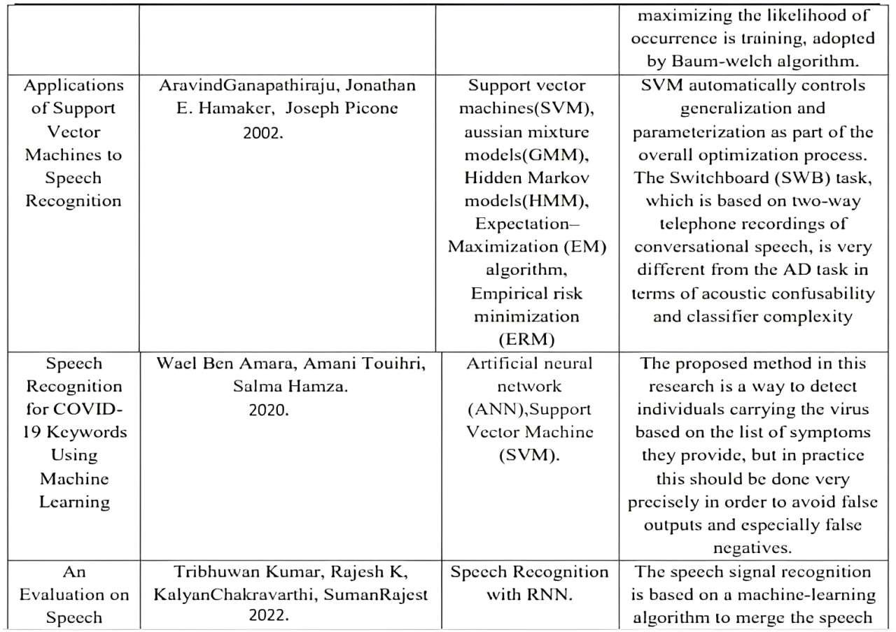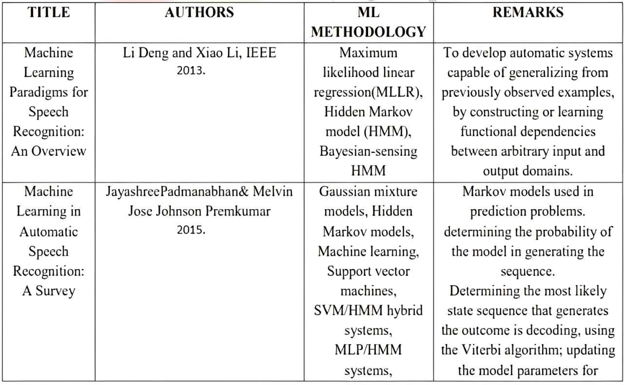

Chapter – 3

System design

### 3.1 ASSUMPTIONS AND DEPENDENCIES

Availability of High-Quality Data:

* It is assumed that sufficient and diverse datasets of speech recordings will be available for training the speech recognition and speaker identification models. These datasets should cover a wide range of accents, languages, speaking styles, and noise conditions.

Consistent Audio Input Quality:

* It is assumed that the audio input for the system will be of reasonable quality, with minimal distortion, enabling the system to correctly process speech and identify speakers. The microphones used are assumed to be of decent quality, providing clear recordings.

Speaker's Voice Characteristics are Consistent:

* It is assumed that individual speakers maintain relatively consistent vocal characteristics (pitch, tone, etc.) over time for the speaker identification system to work effectively.

Limited Number of Speakers in Simultaneous Conversations:

* The system assumes that the number of speakers in a given audio stream will not exceed a manageable threshold (e.g., 2-5 speakers) for successful speaker identification.

Hardware Capabilities:

* The project assumes that devices like the Raspberry Pi 3 B+ or similar hardware platforms can provide enough processing power to handle the speech recognition and speaker identification tasks, albeit with some optimizations for resource efficiency.

Dependencies:

Dataset Quality and Availability:

* The success of the speech recognition and speaker identification models depends heavily on the availability of high-quality, annotated datasets that represent diverse speech samples, including various accents, dialects, and languages. Public or proprietary datasets will be necessary for effective training.

Hardware Resources:

* The performance of the system is dependent on the hardware specifications of the Raspberry Pi or similar devices. Processing power, memory, and storage limitations may affect the real-time performance of speech recognition and speaker identification tasks.

Machine Learning Models:

* The success of this project depends on the development or availability of pre-trained machine learning models for speech recognition and speaker identification. These models need to be optimized for low-latency, on-device processing.

Software Dependencies:

* The system relies on several software dependencies, including Python programming libraries (e.g.,

NumPy, SciPy), machine learning frameworks (TensorFlow, PyTorch), and speech processing

libraries (e.g., SpeechRecognition, librosa).

* Operating system stability (e.g., Raspberry Pi OS) and proper integration of libraries are also critical dependencies.

Noise Handling Techniques:

* The project depends on effective noise-cancellation and signal enhancement techniques, especially for real-world environments where background noise is common. Without robust noise handling, the system’s performance could degrade significantly in noisy conditions.

### 3.2 FUNCTIONAL REQUIREMENTS

The functional requirements of the speech recognition and speaker identification system define the specific actions and operations the system must be able to perform.

1. Speech-to-Text Conversion
   * FR1.1: The system must convert spoken language into accurate textual representations in real time.
   * FR1.2: It should support speech-to-text for multiple languages, provided the language models have been trained or integrated.

1. Speaker Identification
   * FR2.1: The system must accurately identify individual speakers within an audio stream.
   * FR2.2: It should differentiate between multiple speakers in a conversation and tag the corresponding text output with speaker labels (e.g., Speaker 1, Speaker 2).

1. Noise Handling and Signal Enhancement
   * FR3.1: The system must filter out background noise to ensure that the speech is clear and accurately transcribed.
   * FR3.2: It should employ noise-cancellation techniques to process audio recorded in noisy environments.

1. User Interface
   * FR6.1: The system must provide a user-friendly interface to start and stop speech recognition sessions.
   * FR6.2: The interface should allow users to select a language or enroll a new speaker.

1. Security and Privacy
   * FR8.1: The system must ensure the privacy of user data, including voice samples and transcripts, through encryption during storage and transmission.
   * FR8.2: It should allow users to delete their voice profiles and any stored audio data on request.

### 3.3 EXTERNAL INTERFACE REQUIREMENTS

The external interface requirements specify how the speech recognition and speaker identification system interacts with users, hardware, software, and other systems.

## 3.3.1USER INTERFACES

The user interface defines how users interact with the system. It must be intuitive, user-friendly, and provide appropriate feedback to users during speech recognition and speaker identification.

UI1: The system must provide a graphical user interface (GUI) on devices such as desktops, mobile phones, or Raspberry Pi-based platforms.

UI2: The interface should allow users to start, stop, and pause speech recognition sessions with easy-toaccess buttons.

UI3: A clear display of real-time text output from speech recognition should be presented, with different speakers identified and labeled.

UI4: The system must allow users to select from a list of languages for speech recognition.

UI5: The interface should provide a simple enrollment option for adding new speakers to the speaker identification database.

UI6: Error messages or status notifications must be displayed when the system encounters issues, such as low audio quality or a failure to recognize speech.

UI7: A section for history should display the previous transcription records with timestamps and identified speakers.

### 3.3.2 HARDWARE INTERFACES

The system must interact with external hardware components for input (e.g., microphones) and processing (e.g., Raspberry Pi).

HW1: The system must support an external microphone for capturing speech. It should also be able to interface with built-in microphones on laptops and mobile devices.

HW2: The system must run on resource-constrained devices such as the Raspberry Pi 3 B+ and ensure efficient utilization of CPU, memory, and other processing resources.

HW3: It should support connecting to external storage devices (e.g., USB drives or SD cards) for saving audio files or transcripts.

HW4: The system must interface with audio input devices through standard interfaces like 3.5mm jacks, USB, or Bluetooth-enabled microphones.

### 3.3.3 SOFTWARE INTERFACES

The system must interact with various software components, including libraries, databases, and APIs.

* SW1: The system must integrate with external speech-to-text processing libraries (e.g., Google's Speech Recognition API, CMU Sphinx) or custom-trained models.
* SW2: It should be compatible with language models for different languages and support integrating additional models as required.
* SW4: It should interface with cloud services if additional computational resources are required for processing complex models or large data.
* SW5: The system must be compatible with audio processing libraries (e.g., PyAudio or Sound Device) for real-time audio input/output.
* SW6: The system must support a logging system for error tracking, debugging, and performance evaluation (e.g., Python logging library).

### 3.3.4 COMMUNICATION INTERFACES

The system may need to communicate over a network or interact with external systems for various functions like cloud-based processing or data sharing.

* COM1: The system must be able to transmit and receive data (e.g., transcriptions or audio) over a network via standard protocols such as HTTP or HTTPS.
* COM2: If using cloud services for speech recognition, the system must authenticate via API keys or OAuth tokens.
* COM3: It should support Bluetooth or Wi-Fi connections for communicating with external devices, such as wireless microphones or mobile phones.
* COM4: The system must securely transmit any sensitive data (e.g., speaker profiles, audio recordings) using encryption methods like SSL/TLS.

Chapter – 4

System design

### 4.1 SYSTEM ARCHITECTURE

User Interface Layer: Responsible for managing user interactions and displaying transcriptions and identified speakers.

Audio Input Layer: Captures and processes real-time audio data.

Speech Processing Layer: Handles speech recognition and speaker identification using machine learning models.

Database Layer: Manages storage of transcriptions, speaker profiles, and historical data.

Output/Communication Layer: Handles output to users and communication with external systems.

### 4.2 DATA FLOW DIAGRAMS

User Initiates Session

Audio Capture (Microphone)

Audio Preprocessing

Speech-to-Text Engine

Speaker Identification

Transcription Output and Speaker Labeling

Database Storage

User Displays Results/Exports Data.

### 4.3 ENTITY RELATIONSHIP DIAGRAMS

User → provides → Speech_Input

Speech_Input → is processed by → Feature_Extraction

Speech_Input → generates → Transcription (with a link to Language_Model)

Speech_Input → processed by → Speaker_Model → identifies → Speaker

Speech_Input → produces → Recognition_Output (recognized text + speaker)

Chapter - 5

Project Plan

### 5.1 PROJECT ESTIMATE

#### 5.1.1 Reconciled Estimates

Reconciled estimates provide a detailed overview of the expected costs and efforts required for the project. These estimates are carefully reviewed and refined to ensure accuracy and feasibility. Key aspects to consider include:

* Development Costs: Time and resources required to design, implement, and test the system.
* Hardware Costs: Devices like microphones, servers for model training, and cloud storage services if applicable.
* Software Licensing: Any necessary tools, frameworks, or software licenses needed for speech recognition and speaker identification.
* Human Resources: Costs related to the team involved in the project, including developers, data scientists, and project managers.
* Contingency Budget: A portion of the budget allocated for unexpected costs or changes during the project.

#### 5.1.2 Project Resources

The resources required for this project are categorized into Human Resources and Technical Resources.

* Human Resources:
  + Project Manager: Oversees project progress, timeline, and delivery.
  + Data Scientist/ML Engineer: Responsible for training and optimizing the machine learning models.
  + Software Developer: Implements the speech recognition and speaker identification system.
  + Testers: Ensure the system meets performance and accuracy standards.

* Technical Resources:
  + Raspberry Pi 3 B+: For edge computing and model deployment, if the system is designed for hardware-based usage.
  + Microphone: High-quality microphone for clear audio input.
  + Machine Learning Tools: Libraries such as TensorFlow, Keras, or PyTorch for developing speech recognition models.
  + Speech Datasets: High-quality datasets for training models on both speech-to-text and speaker identification tasks.

### 5.2 RISK MANAGEMENT

#### 5.2.1 Risk Identification

Risk identification involves recognizing potential issues that could hinder the progress, performance, or outcome of the project. For this machine learning-based speech recognition and speaker identification system, the risks may include:

* Technical Risks:
  + Model Accuracy: The machine learning models may not achieve the desired accuracy, leading to incorrect speech-to-text conversion or speaker misidentification.
  + Data Quality: Low-quality or insufficient training data may result in poor model performance.
  + Hardware Limitations: The Raspberry Pi or other hardware may struggle to process complex machine learning models in real-time.
  + Integration Issues: Problems may arise when integrating various components like microphones, the machine learning model, and output systems.
* Resource Risks:
  + Skill Shortage: Lack of experienced developers, machine learning engineers, or data scientists may delay the project.
  + Time Constraints: The team may face time pressures to deliver the project within the deadlines, risking incomplete or poor-quality solutions.
* External Risks:
  + Technological Advancements: The rapid evolution of machine learning techniques could make the chosen methods obsolete or less effective.
  + Legal/Compliance Risks: Using speech data might pose privacy concerns, especially when handling speaker identification.
* Project Management Risks:
  + Budget Overruns: Unanticipated expenses could lead to budgetary constraints, resulting in cutbacks or project delays.
  + Scope Creep: Uncontrolled changes or additions to the project scope may affect timelines and deliverables.

#### 5.2.2 Risk Analysis

Risk analysis evaluates the likelihood of the identified risks and their potential impact on the project. Each risk is categorized by its probability of occurring (Low, Medium, High) and its severity (Low, Medium, High). This analysis helps prioritize risks for mitigation.

* Model Accuracy:
  + Probability: Medium o Impact: High
  + Mitigation: Continuously monitor model performance using cross-validation and fine-tune the model using hyperparameter optimization.
* Data Quality:
  + Probability: High o Impact: High
  + Mitigation: Use diverse and high-quality datasets. Implement data augmentation techniques to improve training data quality.
* Hardware Limitations:
  + Probability: Medium o Impact: Medium o Mitigation: Offload heavy processing tasks to a more powerful cloud server, if needed. Optimize models for edge devices to reduce computational load.
* Skill Shortage:
  + Probability: Low o Impact: High
  + Mitigation: Upskill existing team members through training and workshops. Consider outsourcing if necessary.
* Time Constraints:
  + Probability: Medium o Impact: High
  + Mitigation: Implement efficient project management techniques, including Agile practices, to monitor progress and ensure milestones are met on time.
* Budget Overruns:
  + Probability: Low o Impact: High
  + Mitigation: Establish a contingency budget early on and closely monitor expenses throughout the project.

### 5.3 PROJECT SCHEDULE

The project schedule outlines the key tasks and milestones that need to be completed over the course of the project, providing a clear timeline for each phase. Below is the monthly-wise breakdown of tasks for the Machine Learning-Based Speech Recognition and Speaker Identification System.

#### 5.3.1 Project Task Set

Month 1: Project Initialization and Requirement Gathering • Task 1.1: Define project objectives and scope.

* Task 1.2: Gather detailed functional and non-functional requirements.
* Task 1.3: Identify key stakeholders and set up communication channels.
* Task 1.4: Conduct initial research on existing speech recognition technologies and available datasets.
* Task 1.5: Draft and review the project plan with timelines.

Month 2: System Design and Data Collection

* Task 2.1: Design system architecture (hardware setup, data flow, model integration).
* Task 2.2: Design the database and data structures needed for speech and speaker data storage.
* Task 2.3: Set up hardware infrastructure (Raspberry Pi, microphones, etc.).
* Task 2.4: Start collecting and preprocessing speech datasets for training.
* Task 2.5: Research speaker identification techniques and define a methodology.

Month 3: Model Development and Training

* Task 3.1: Develop the speech-to-text model using a suitable machine learning framework (e.g., TensorFlow, PyTorch).
* Task 3.2: Train the speech recognition model using collected datasets.
* Task 3.3: Implement speaker identification functionality, beginning with feature extraction.
* Task 3.4: Start experimenting with different algorithms for speaker identification (e.g., MFCC,

GMM, CNN).

* Task 3.5: Set up real-time audio processing pipeline on Raspberry Pi.

Month 4: Model Testing and Evaluation

* Task 4.1: Test the speech recognition model on test data and measure accuracy, speed, and performance.
* Task 4.2: Test the speaker identification model and measure its effectiveness in distinguishing between speakers.
* Task 4.3: Fine-tune models by adjusting hyperparameters, modifying architectures, or using additional data.
* Task 4.4: Conduct stress testing on hardware for performance benchmarking.
* Task 4.5: Document model performance metrics and evaluate them against project goals.

Month 5: Integration and System Testing

* Task 5.1: Integrate the speech recognition and speaker identification models into a unified system.
* Task 5.2: Conduct end-to-end testing of the system (speech recognition, speaker identification, and response time).
* Task 5.3: Validate the system on real-time audio inputs.
* Task 5.4: Ensure compatibility with external interfaces (microphone, output device, cloud, etc.).
* Task 5.5: Collect user feedback and improve system usability.

Month 6: Optimization and Final Deliverables

* Task 6.1: Optimize the system for performance (memory usage, CPU load, real-time

performance).

* Task 6.2: Resolve any remaining bugs and refine the user interface.
* Task 6.3: Conduct final testing and validation with stakeholders.
* Task 6.4: Prepare the final project documentation (technical report, user manual).
* Task 6.5: Deliver final project to stakeholders and present findings and results.

Chapter - 6

Project Implementation

### 6.1 OVERVIEW OF PROJECT MODULES

The project "Machine Learning-Based Speech Recognition System" can be divided into several key modules. Each module focuses on a specific function of the system, and together, they form the complete solution for converting speech to text and identifying speakers using machine learning.

1. Speech Acquisition Module

This module is responsible for collecting speech input from users. The input can be live speech captured via a microphone or pre-recorded audio files.

* + Components:
    - Microphone (Hardware) o Preprocessing (noise reduction, normalization)
    - Audio segmentation (splitting continuous audio into manageable chunks)

1. Speech Preprocessing Module

The raw audio data must be processed before it can be used for speech recognition or speaker identification. This module handles preprocessing techniques such as filtering, denoising, and feature extraction.

* + Tasks:
    - Convert raw audio into a usable format (e.g., WAV) o Apply filters to remove background noise
    - Extract relevant features (e.g., MFCC – Mel Frequency Cepstral Coefficients)

1. Speech Recognition Module

This module handles the conversion of speech input into text. Using a machine learning model or a deep learning-based neural network, it translates spoken words into text format.

* + Key Functions:
    - Automatic Speech Recognition (ASR) using machine learning o Text output generation

1. Speaker Identification Module

The objective of this module is to identify the speaker from the input audio. This is accomplished by extracting unique speaker characteristics (voiceprint) and comparing them with known speakers in a database.

* + Key Functions:
    - Feature extraction for speaker identification (MFCC, LPC, etc.)
    - Use of machine learning models such as Gaussian Mixture Models (GMM), Support

Vector Machines (SVM), or neural networks for identifying the speaker o Verification and matching with a speaker database

1. Machine Learning/Modeling Module

This is the core of the system, where machine learning techniques are applied to build and train models for both speech recognition and speaker identification.

* + Tasks:
    - Model selection and training for speech recognition (e.g., recurrent neural networks,

LSTM)

* + - Training models for speaker identification using supervised learning o Hyperparameter tuning for optimization

1. User Interface Module

The user interface allows the user to interact with the system. The UI must be intuitive and responsive to the needs of both speech recognition and speaker identification functionalities.

* + Features:
    - Input options (record speech, upload audio file) o Display of recognized text output o Speaker identification display

1. Database Module

The database stores user data, such as previously identified speakers and recognized text. It helps in tracking and managing speaker profiles and related metadata.

1. System Integration Module

This module integrates all the other modules, ensuring that data flows smoothly between them. It also handles tasks such as syncing audio data with the recognition model, running background processes, and managing system resources.

1. Testing and Validation Module

This module ensures that the system works as intended by running tests and validations on all aspects of the project. This includes unit testing, integration testing, and performance testing.

Chapter – 7

Results

### 7.1 OUTCOMES

Speech to text conversion application has been successfully implemented using Raspberry Pi. This application is useful for presentations in conferences and classrooms. Raspberry Pi is used along with monitor has been used in this Application to display text on the Monitor. The conversion of speech to text and display has been observed to be consistent and reliable.

The system will successfully identify the speaker based on their unique vocal characteristics, enabling multispeaker environments to be analyzed and tracked in real-time.

The automation of transcribing speech into text and identifying speakers will save time in many professional settings, such as interviews, legal proceedings, and educational contexts, thus improving productivity.

Machine learning models will be optimized for accuracy and performance, ensuring the system functions with minimal latency and can process audio inputs efficiently even on lower-end hardware like Raspberry Pi.

### 7.2 SCREEN SHOTS

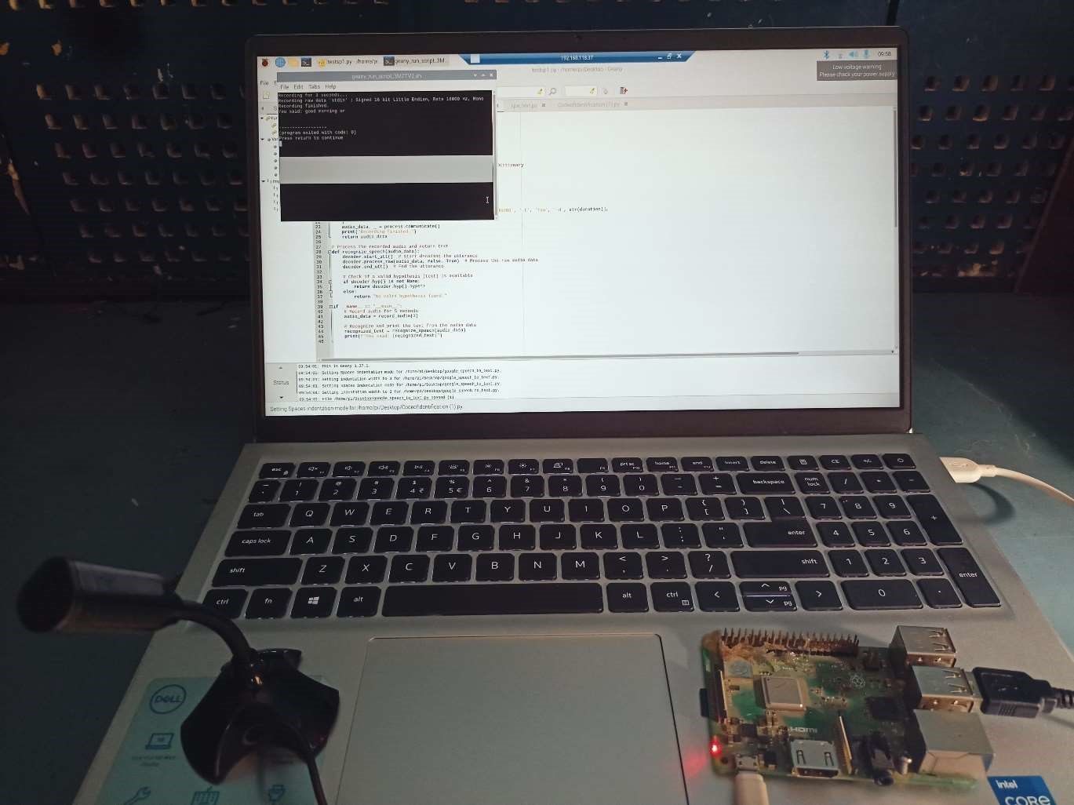

Chapter – 8

Conclusions

8.1 CONCLUSION

In conclusion, this project successfully demonstrates the design and implementation of a Machine Learning-Based Speech Recognition System. Through the integration of speech-to-text conversion and speaker identification algorithms, the system addresses the growing need for automation in voice processing tasks.

This project presented the development of a machine learning-based speech recognition system implemented in Python and deployed on a Raspberry Pi. Through careful model selection, optimization, and efficient implementation, the system successfully converts speech into text in real-time while operating within the hardware constraints of the Raspberry Pi.

Overall, this project serves as a stepping stone towards more advanced speech recognition systems that will continue to evolve with the advancement of machine learning and artificial intelligence technologies.

### 8.2 FUTURE WORK

Improved Accuracy and Robustness:

* Noise Reduction: The system can be further optimized for noisy environments by integrating more advanced noise-canceling algorithms or robust acoustic models to improve speech recognition in real-world conditions.
* Accent and Dialect Adaptation: Incorporating models that adapt to different accents, dialects, and languages can improve accuracy for diverse user populations.

Real-time Performance Optimization:

* As real-time applications grow in importance, optimizing the system for faster processing and lower latency will be critical. Techniques such as model compression, quantization, and efficient neural network architectures (like transformers) can be explored to enhance real-time performance.

Scalability to Larger Datasets:

* The current model can be expanded to work on larger and more diverse datasets, which would improve its generalizability across different languages, environments, and speaking styles.

Integration with Natural Language Processing (NLP):

* Integrating speech recognition with advanced NLP techniques could enable context-aware understanding, allowing for better handling of homophones, sentence structure, and contextual meanings.

Multi-Speaker Conversations:

* Developing the system to handle more complex scenarios like identifying multiple speakers in overlapping conversations (i.e., diarization) would increase its applicability in settings such as meetings or conference calls.

Emotion and Sentiment Detection:

* Enhancing the system to not only recognize speech and speakers but also detect emotions or sentiment can unlock further applications in customer service, mental health monitoring, and virtual assistants.

Deployment to Edge Devices:

* With the increasing need for privacy-preserving systems, enabling on-device processing for edge devices such as smartphones, smart home systems, or IoT devices could minimize the need for cloud-based processing, ensuring user privacy and reducing latency.

Security and Privacy Considerations:

* Ensuring secure data transmission and compliance with privacy standards (like GDPR) can make the system more viable for industries like healthcare and legal services, where data security is paramount.

User Interface Improvements:

* Creating more user-friendly interfaces for interacting with the system, such as visual feedback for the identified speaker or voice-guided commands, could improve usability and adoption.

#### 8.3 Applications

* Voice search: a digital assistant to help surf the web and search through to help accomplish different Tasks.
* A Speech Recognition System is quite useful in classrooms and presentations.
* A speech-to-text conversion and display can also improve system accessibility by providing data entry options for blind, deaf, or physically handicapped users.
* Virtual assistants: These voice- activated assistants can perform tasks like making calls, playing music send messages.
* Smart Homes: Integrating this system into smart devices like Amazon Alexa, Google Home, or smart TVs enables users to control home appliances, search the internet, or perform tasks via voice commands.
* Speaker Identification: Call centers can use the system to authenticate users based on their voice, improving security and enhancing customer service efficiency.
* Automatic Transcription: The system can transcribe customer calls in real-time, making it easier for support agents to follow up on conversations and analyze customer feedback. Ex. Google

Assistant

* Lecture Transcription: Automatically transcribe lectures into texts and make the content accessible to students with different learning needs.
* Speech recognition enables hands free computing. Its use cases include, but are not limited to: Writing Emails, Composing a document on Google Docs, Automatic closed captioning with speech recognition (i.e. YouTube), Automatic translation, And sending texts.
* Healthcare: Doctors and nurses leverage dictation applications to capture and log patient diagnoses and Treatment notes.
* Speech recognition technology has a couple of applications in sales. It can help a call center transcribe Thousands of phone calls between customers and agents to identify common call patterns and issues.
* Security: As technology integrates into our daily lives, security protocols are an increasing priority. Voice-based authentication adds a viable level of security.

##### BIBLIOGRAPHY

1. J. Kim, R. Gupta, and A. Patel "Advances in Deep Learning for Speech Recognition Systems" IEEE International Conference on Acoustics, Speech and Signal Processing (ICASSP), May 2024.

1. Dr. H S Prasantha “Detailed Survey of Speech Recognition using Machine Learning Algorithms” International Journal Of Creative Research Thoughts Volume 11,Issue 11, ISSN 2320-2882, November 2023.

1. Tribhuwan Kumar, Rajesh K,KalyanChakravarthi, SumanRajest "An Evaluation on Speech Recognition Technology based on Machine Learning" Webology, Volume 19, Number 1, January, 2022.

4.VineetVashisht, Satya Prakash yadav, Aditya Kumar pandey. “Speech Recognition Using Machine Learning”. Article in IEIE Transactions on Smart Processing and Computing · June 2021

1. Wael Ben Amara, Amani Touihri2, Salma Hamza "Speech Recognition for COVID-19 Keywords Using Machine Learning" Vol.8, Issue.4, pp.51-57, August (2020).

1. Heigold, G., Moreno, I. L., Bengio, S., & Shazeer, N. (2016). End-to-end text dependent speaker verification. IEEE International Conference on Acoustics, Speech and Signal Processing (ICASSP).

1. Zheng, Z., Zhao, J., Xu, W., & Lin, C. (2021). Research and development of voiceprint recognition technology. Journal of Physics: Conference Series.

1. Ravanelli, M., & Bengio, Y. (2019). Speaker recognition from raw waveform with SincNet. IEEE/ACM Transactions on Audio, Speech, and Language Processing.

1. ysSnyder, D., Garcia-Romero, D., Sell, G., Povey, D., & Khudanpur, S. (2018). X-vectors: Robust DNN embeddings for speaker recognition. IEEE International Conference on Acoustics, Speech and Signal Processing (ICASSP).